EXPT NO:7 | OVER-PLOTTING REDUCTION TECHNIQUES
DATE: 09.02.2026 | OVER-PLOTTING REDUCTION TECHNIQUES

PRE-LAB QUESTIONS
- Why is over-plotting common in big data visualization?
Over-plotting occurs when a large number of data points overlap in the same visual space. In big datasets, especially those containing millions of records such as social media interactions, many observations share similar values, causing points to stack on top of each other and hide underlying patterns.

- How does data density affect perception?
High data density makes it difficult to distinguish individual points, leading to visual clutter. Dense regions may appear as solid blocks, preventing accurate interpretation of trends, clusters, or outliers.

- What trade-offs exist between detail and clarity?
Displaying raw data preserves detail but reduces clarity due to overlap. Aggregation and binning improve clarity but sacrifice individual data precision. The choice depends on analytical goals

- How do AI datasets increase visualization complexity?
AI datasets are large, multi-dimensional, and generated at high frequency.
This results in heavy overlap of data points in visualizations. Traditional plots become cluttered without over-plotting reduction techniques.

- Why is over-plotting a serious analytical risk?
Over-plotting hides important trends and patterns in data. It can exaggerate or mask data density and anomalies. This leads to incorrect analysis and poor decision-making.

OBJECTIVE :
To apply techniques that reduce visual clutter in large-scale datasets.

SCENARIO A social media analytics company visualizes millions of user interactions to study engagement patterns.

IN-LAB TASKS (Using R Language)

• Apply alpha blending
• Implement jittering techniques
• Use aggregation and binning

Code:

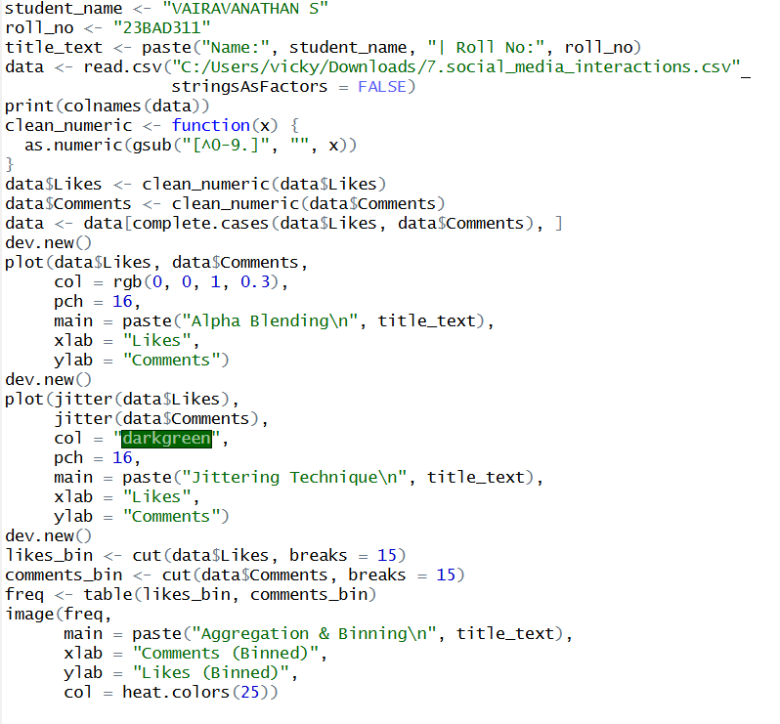

Output:
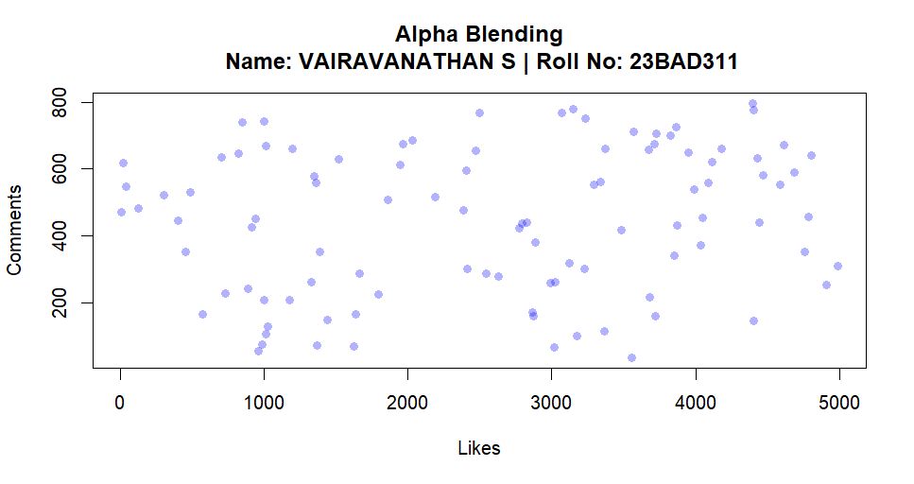

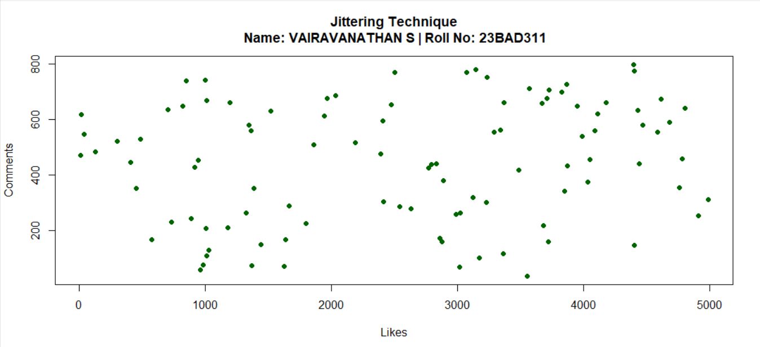

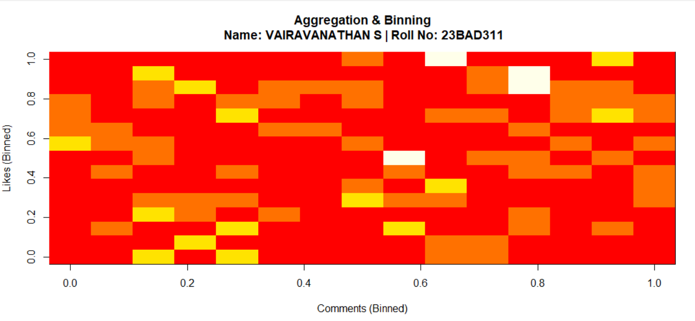

POST-LAB QUESTIONS
- Which technique provided the best clarity and why?
Aggregation and binning provided the best clarity because it groups a large number of overlapping data points into bins based on their frequency. Instead of plotting millions of individual interactions, this method summarizes data density using colour intensity. This makes it easy to identify high-engagement regions and overall patterns without visual clutter, especially in large-scale social media datasets.
- How does over-plotting distort analytical conclusions?
Over-plotting distorts analytical conclusions by hiding the true distribution of data points. When many points overlap, dense regions may appear less important, while sparse areas may seem more significant than they actually are. This can mask trends, hide clusters, and conceal outliers, leading analysts to draw incorrect conclusions about user behaviour and engagement levels.
- When should aggregation be preferred over raw plotting?
Aggregation should be preferred when dealing with very large datasets where plotting every individual data point is impractical. It is especially useful when the goal is to understand overall trends, density patterns, or correlations rather than individual data values. Aggregation improves readability, reduces computational load, and enhances interpretability in big data analysis.
- How do these techniques support scalable AI analytics?
Over-plotting reduction techniques support scalable AI analytics by enabling clear visualization of massive datasets generated by AI systems. Alpha blending, jittering, and aggregation help analysts quickly interpret model outputs, detect patterns, and validate results without being overwhelmed by data volume. These techniques ensure that AI-driven insights remain interpretable as data size grows.
- Explain real-world consequences of ignoring over-plotting.
Ignoring over-plotting can hide important data patterns such as high-engagement users or abnormal activity. This may lead to incorrect business decisions, poor content strategies, and ineffective advertising. In AI systems, hidden patterns can cause biased models and inaccurate predictions. Overall, it results in unreliable insights and loss of trust in analytical outcomes.

LEARNING OUTCOME: Students master over-plotting reduction for big data visual analytics.

ASSESSMENT
Description | Max Marks | Marks Awarded
Pre Lab Exercise | 5
In Lab Exercise | 10
Post Lab Exercise | 5
Viva | 10
Total | 30
Faculty Signature

